Input Layer

Output Layer

Hidden Layer

Hidden Layer

Hidden Layer

Design a neural network diagram with:

5 neurons in input Layer

4 neurons in hidden layer 1

4 neurons in hidden Layer 2

3 Neurons in hidden Layer 3

1 Neuron in output Layer

**Forward Propagation Step-by-Step**

**Step 1: Input Layer**

The input layer consists of:

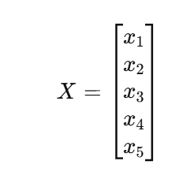

It is passed to the first hidden layer.

__________________________________________________________________________________-

**Step 2: Hidden Layer 1 Calculations**

**1. Compute Linear Combination**

Z1​=W1​X

Where:

* W1​ is a 4×5 weight matrix.
* X is a 5X1 column vector.
* B1 is a 4 X 1 bias vector.

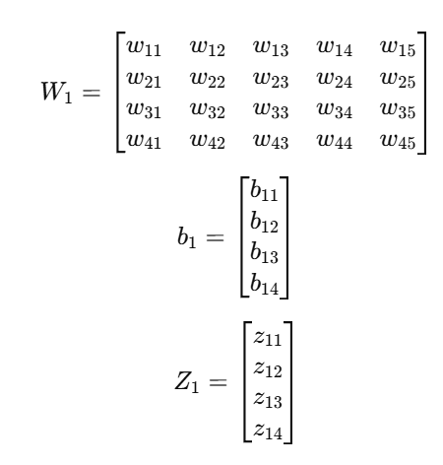

**2. Apply Activation Function**

*A1​=f(Z1​) +b1*

A1​ serves as input for the next layer.

_______________________________________________________________________________

**Step 3: Hidden Layer 2 Calculations**

Z2=W2A1

Where:

* W2 is a 4x4 weight matrix.
* A1 is a 4×1 column vector.
* B2 4×1 bias vector.

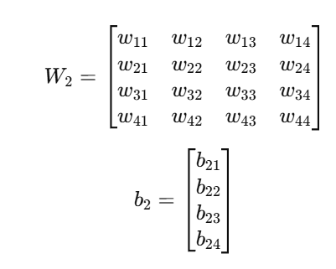

Applying activation:

*A2 = f(Z2) + b2*

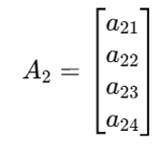

_________________________________________________________________________________

**Step 4: Hidden Layer 3 Calculations**

Z3 = W3A2

Where:

* W3 is a 3×4 weight matrix.
* A2 is a 4 X 1 column vector.
* b3 is a 3 X 1 bias vector.

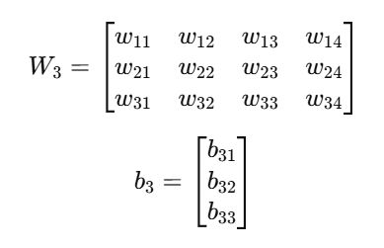

Applying activation:

*A3 = f(Z3) + b3*

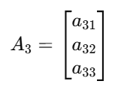

___________________________________________________________________-

**Step 5: Output Layer Calculations**

Z4 = W4A4

Where:-

* W4 is 1 X 3 weight matrix.
* A3 is 3 X 1 column vector.
* b4 is 1 X 1 bias value.

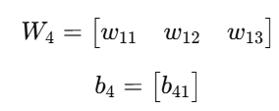

Applying Activation:-

*A4 = f(Z4) + b4*

Since A4 is a single value, it represents the final output.